|  |
| --- |
| **Sporty Shoes**  **(Application Screenshot)** |

**Version History:**

|  |  |
| --- | --- |
| Author | Nikhil Jain |
| Purpose | Screenshot of the application |
| Date | 11th November 2021 |
| Version | 1.0 |

Contents

1. Homepage 3

2. Login Page 4

3. Registration Page 5

4. Admin Dashboard 6

5. Add Product 7

6. Purchase History 8

7. Registered Users 9

8. Cart 10

9. Checkout 11

10. Confirmation Page 12

# Homepage

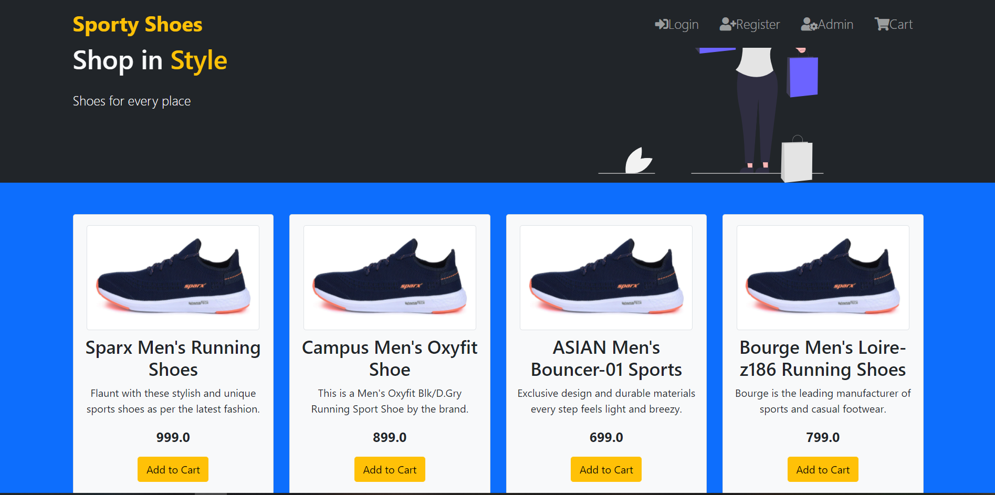

# Login Page

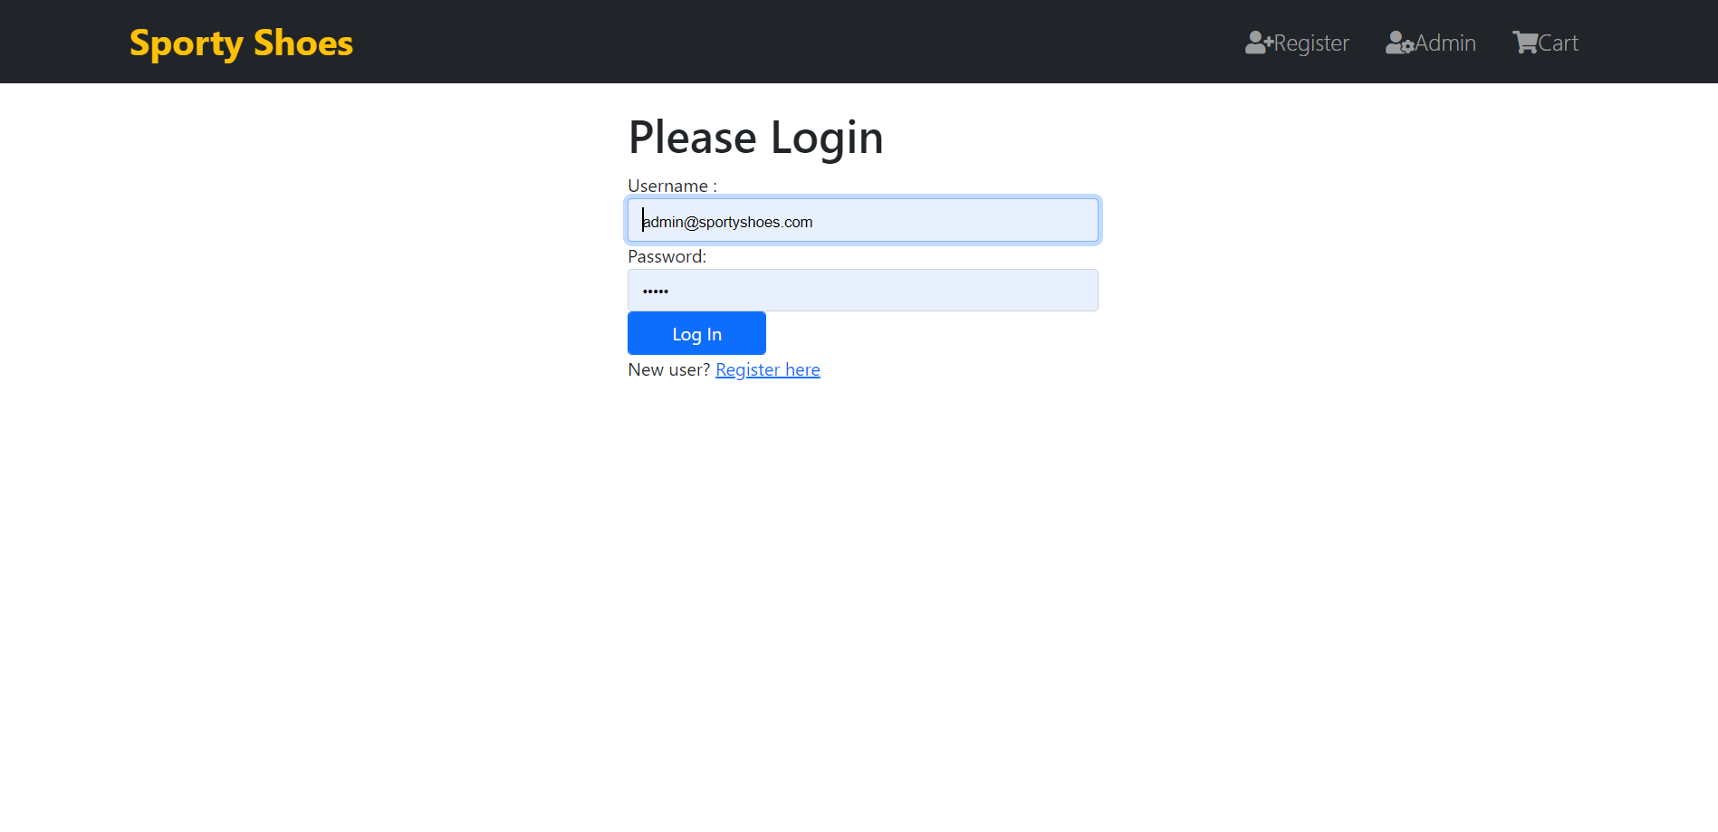

# Registration Page

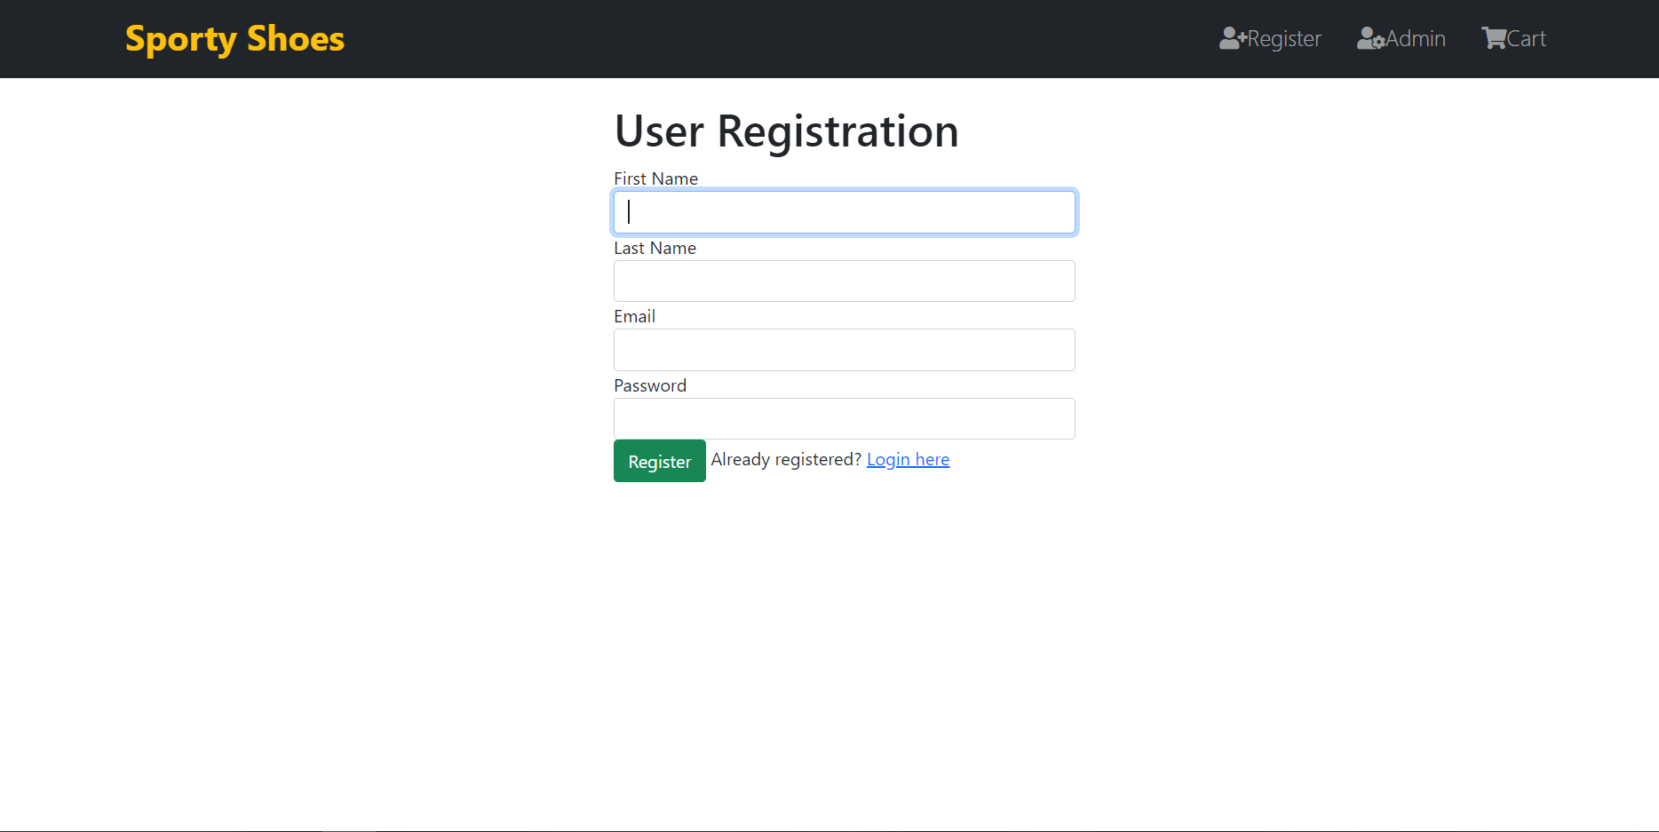

# Admin Dashboard

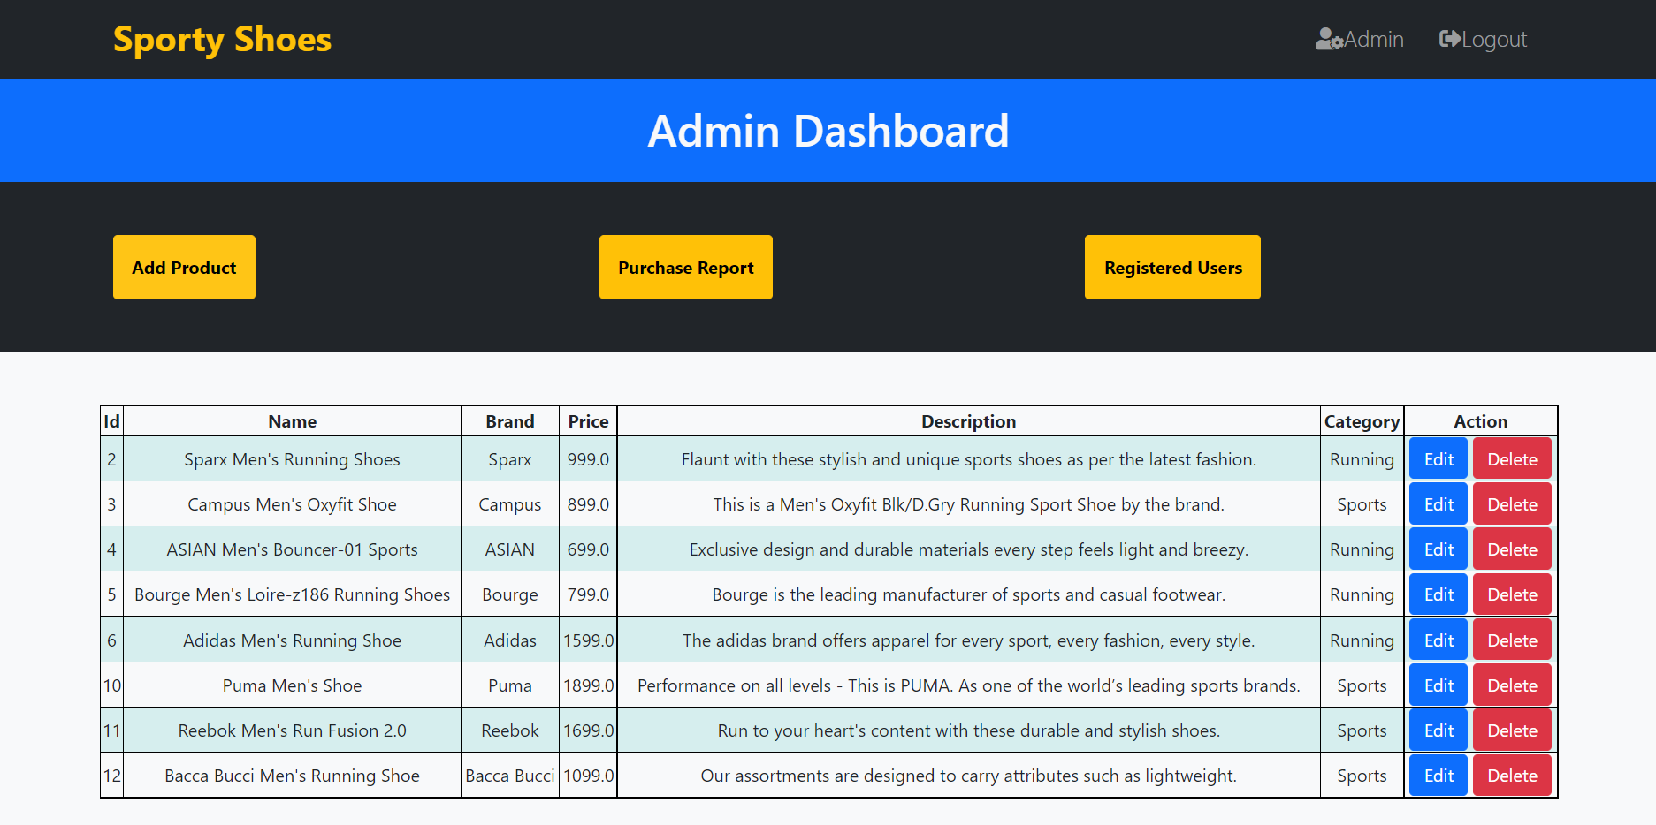

# Add Product

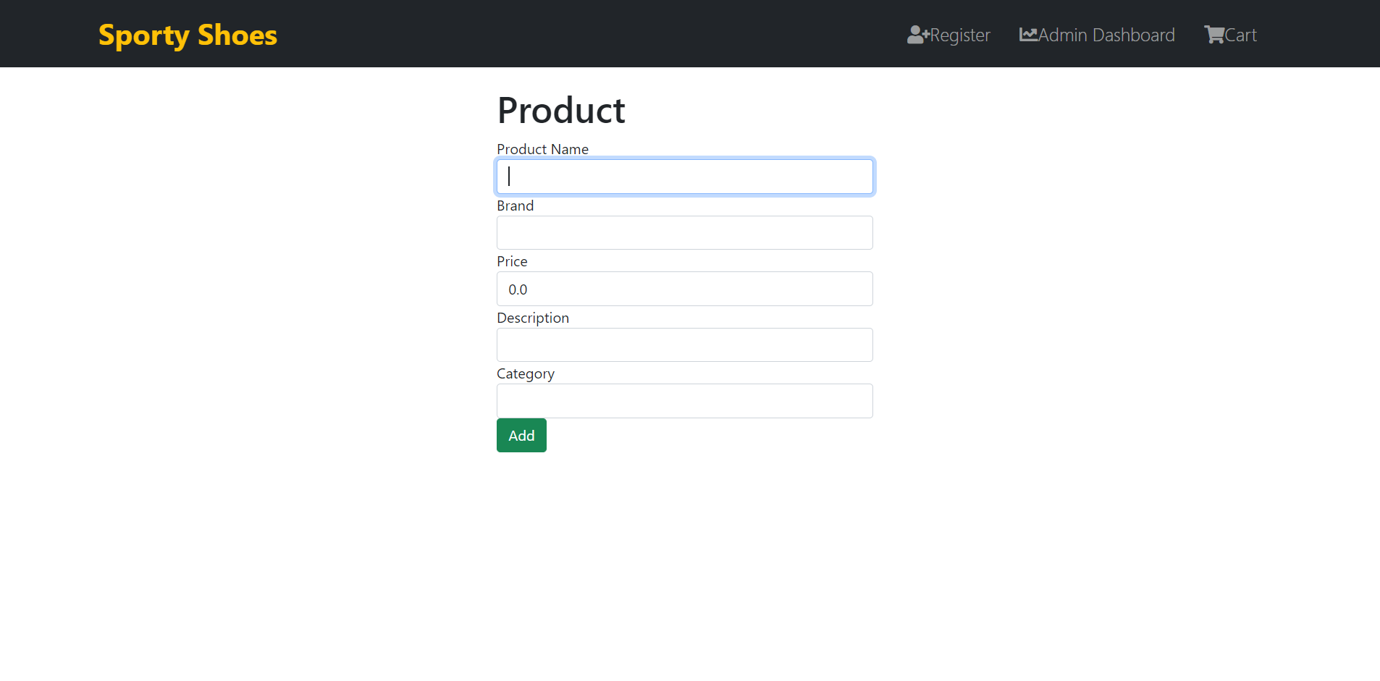

# Purchase History

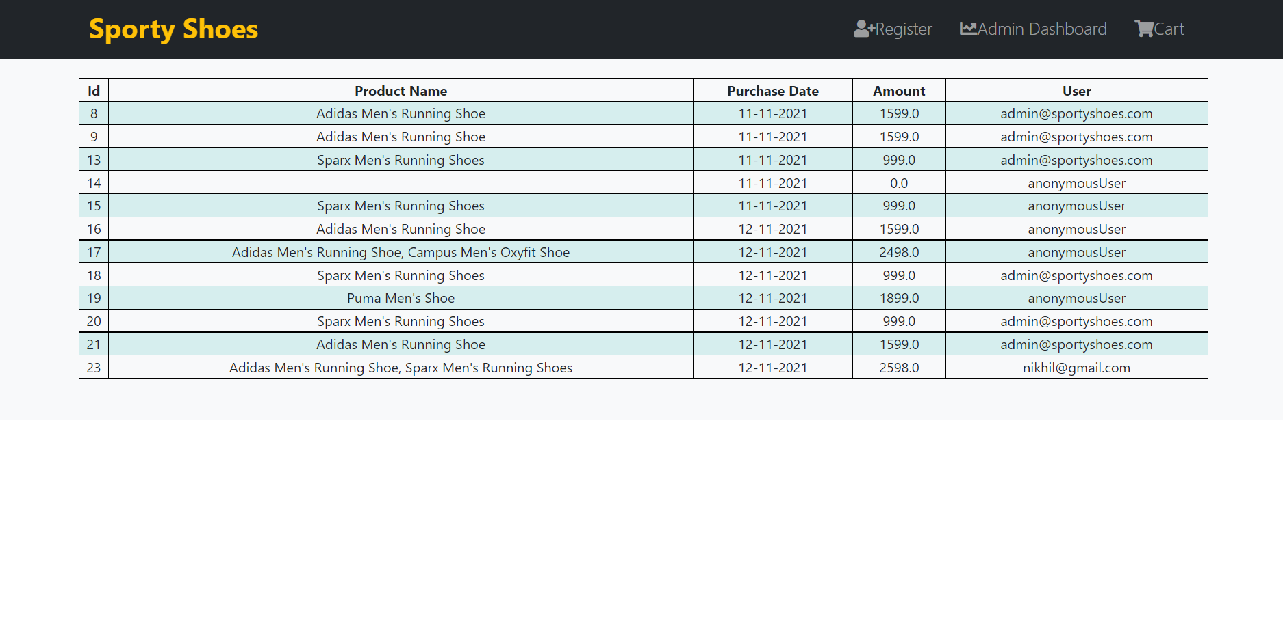

# Registered Users

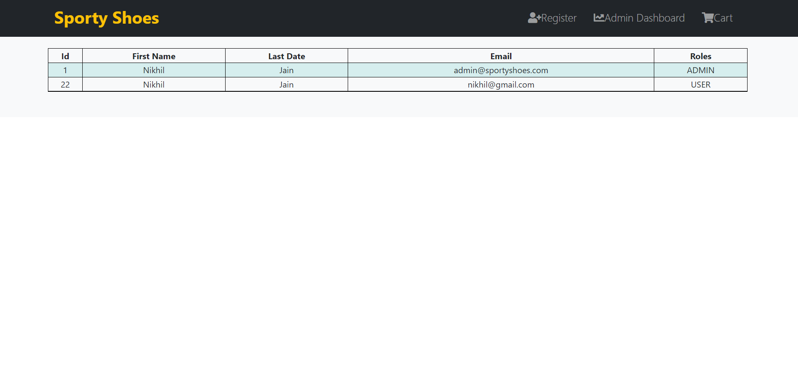

# Cart

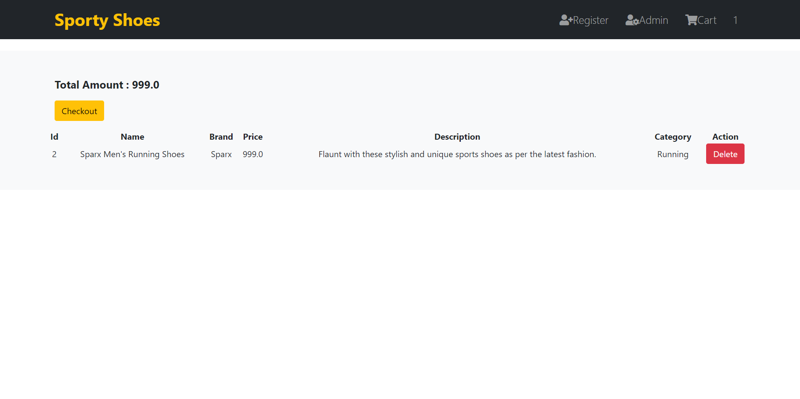

# Checkout

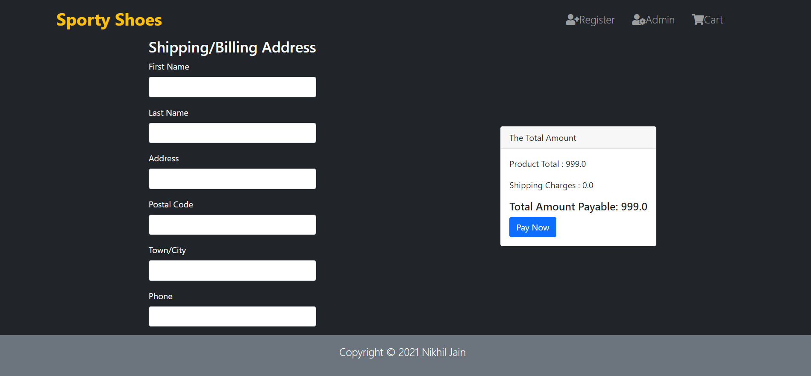

# Confirmation Page

